
International UNIVERSITY OF Business Agriculture and TECHNOLOGY
Project Report on Student Management System
Course Code-CSC440 (Visual Programming)

Submitted To
Suhala Lamia Faculty
Department of Computer Science and Engineering

Submitted By
Name | Id | Signature
Shuvo Khondokar | 18103236
Osman Gani Mridul | 21103005
MD Asaduzzaman | 20303007

Section-C
Program: BCSE
Date of Submission: 19/08/2023



Table of Contents
Table of Contents 2
Introduction 3
User Requirements 4
Used Technology 5
User Interface 6
Home Interface 6
Course Interface 6
Batch Interface 7
User Interface 8
Controller 9
Home Controller 9
User Controller 9
Index Controller 10
Conclusion 11

Introduction

The Student Management System is a comprehensive web application developed using C# and ASP.NET MVC that aims to streamline and enhance the management of student-related tasks within an educational institution. This system provides a user-friendly interface for administrators, teachers, and students, allowing them to efficiently handle various aspects of student information, academic records, and administrative processes.

The primary objective of the Student Management System is to automate and digitize the traditional manual processes involved in student management, resulting in increased efficiency, accuracy, and accessibility of crucial information. By harnessing the power of modern web technologies, this system empowers educational institutions to optimize their operations and better focus on the educational experience of their students.

Student Management System is software which is helpful for students as well as the school
authorities. In the current system all the activities are done manually. It is very time consuming and costly. Our Student Management System deals with the various activities related to the students

User Requirements

The student management system has been designed to cater to the following user requirements:

- Course Management: The system should allow administrators to define and manage courses offered by the institution. This includes specifying course details, duration and faculty.

- Batch Management: Administrators should be able to create and manage batches for each batch and years.

- Registration Process: The system should facilitate student registration for courses and batches and also including first name, last name, and nickname and telephone number of users. It should provide a user-friendly interface for students to select desired courses and batches and complete the registration process.

- User Roles and Access: The system should support different user roles, such as administrators, teachers, and students. Each role should have appropriate access levels and permissions based on their responsibilities.

- User Profiles: Users should be able to create and manage their profiles, which include personal details, contact information, and roles within the institution.

- Communication: The system should incorporate communication tools, like messaging or announcements, to enable effective communication between administrators, teachers, and students.

- Enrollment Tracking: The system should maintain records of student enrollments in courses and batches, allowing administrators and teachers to monitor student participation.

Used Technology

The student management system is developed using C# ASP.NET MVC, which offers a robust framework for building dynamic web applications. The following technology stack is employed:

- ASP.NET MVC Framework: Provides a structured architecture for developing web applications, facilitating separation of concerns (Model-View-Controller) and promoting scalability.

- Entity Framework: Utilizes Entity Framework for efficient database interaction, allowing seamless management of course details, batch schedules, and user profiles.

- SQL Server Database: Leverages SQL Server as the backend database management system to store and retrieve student information, course data, and enrollment or registration details.

- Authentication and Authorization: Implements ASP.NET Identity for secure user authentication and authorization, enabling role-based access control.

- Scaffolding: Utilizes scaffolding to automatically generate CRUD operations for database entities, saving development time and effort.

- AJAX and jQuery: Utilizes AJAX and jQuery for asynchronous data loading and improved user interactivity.

- Data Visualization: Integrates charting libraries like Chart.js to visualize enrollment trends, course popularity, and other relevant insights.

- Security Measures: Implements secure coding practices, input validation, and authorization filters to ensure data security and privacy.

By leveraging automatic CRUD operations through scaffolding in conjunction with the capabilities of the ASP.NET MVC framework, the student management system offers a comprehensive solution for managing student information and enhancing collaboration within educational institutions.

User Interface

Home Interface
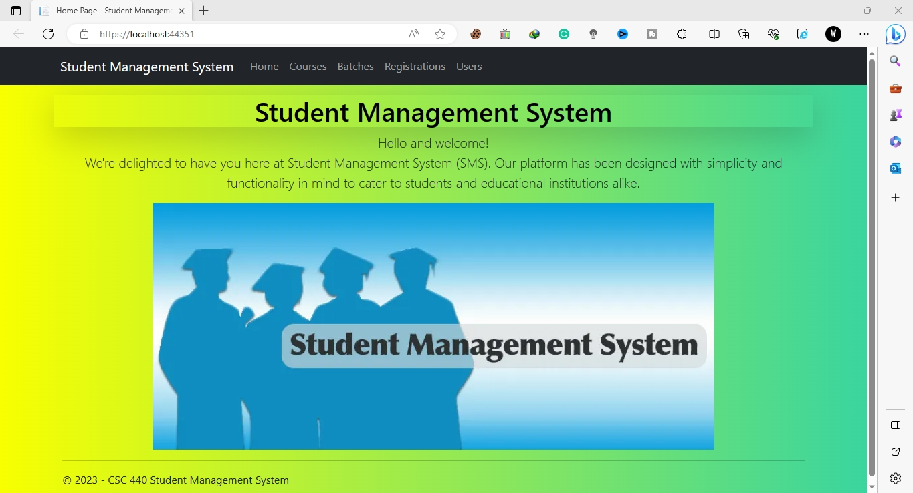

Course Interface
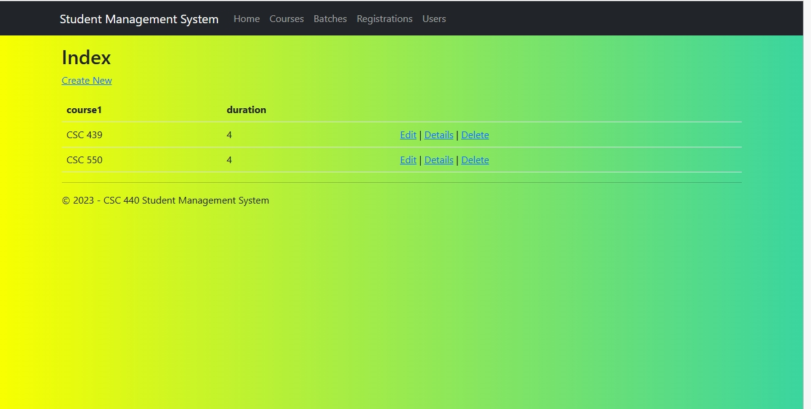

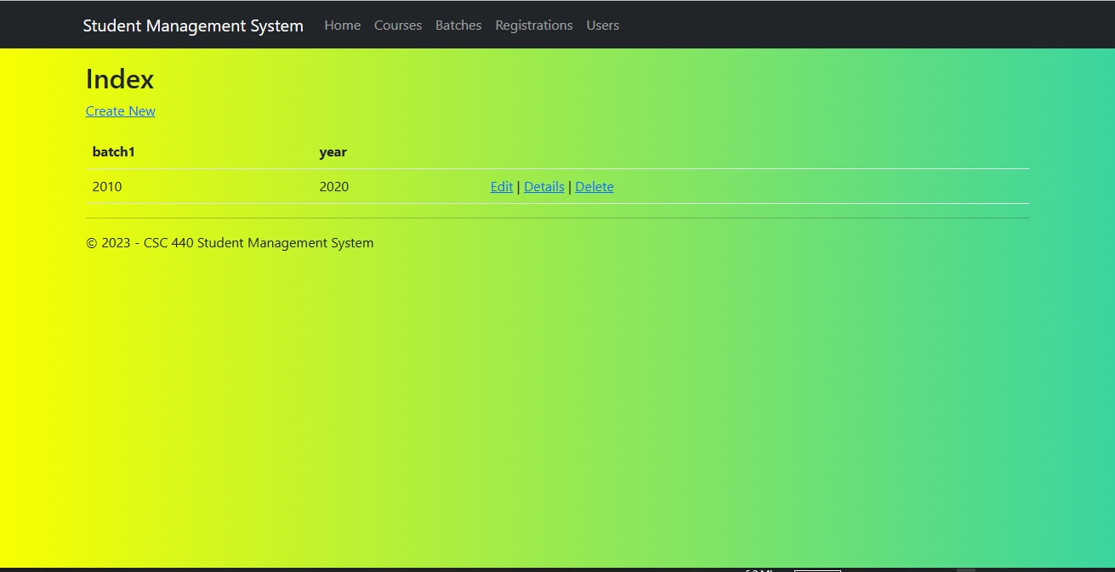
Batch Interface

Registrations Interface

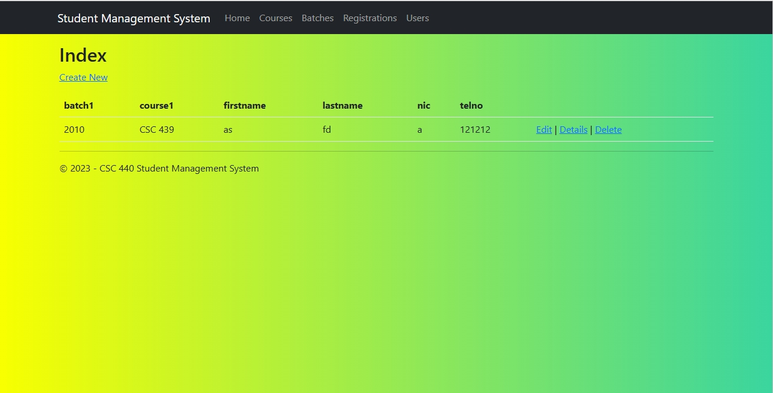

User Interface
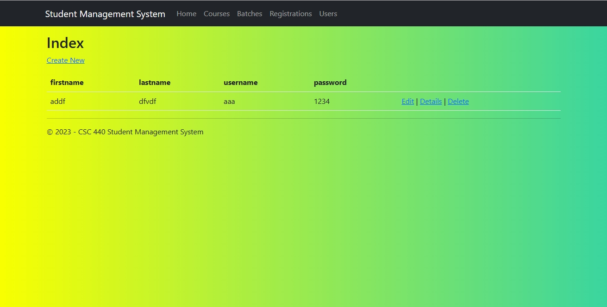

Controller

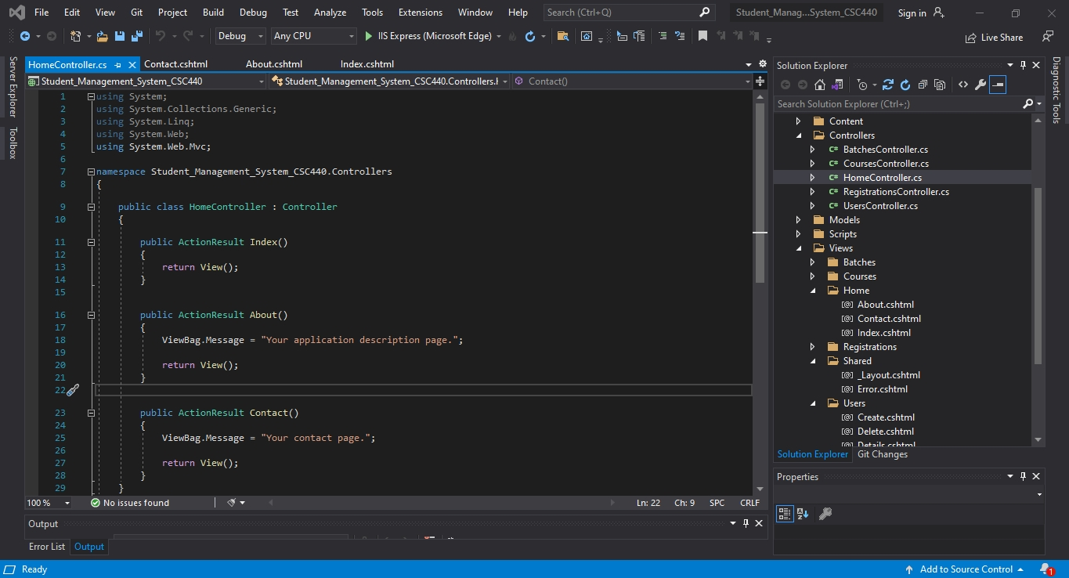
Home Controller

User Controller
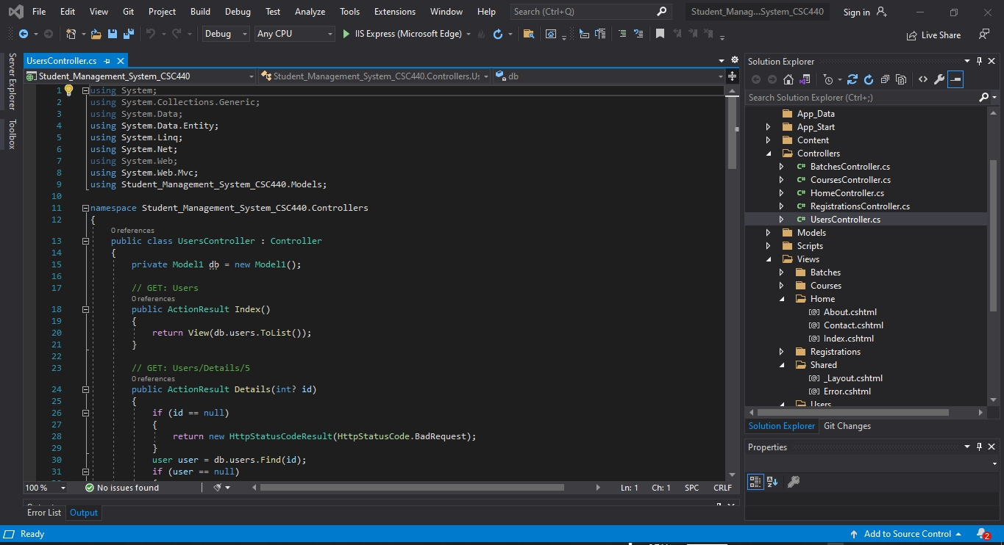

Index Controller

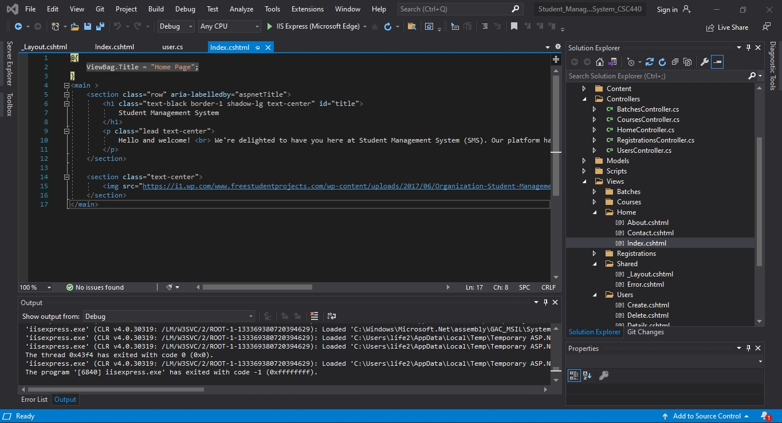

Conclusion

The student management system developed using C# ASP.NET MVC effectively meets user requirements related to course management, batch scheduling, registrations, user roles, and communication. By leveraging the capabilities of the ASP.NET MVC framework and associated technologies, the system provides a comprehensive solution for managing student information and enhancing collaboration within educational institutions.

Our project is only a humble venture to satisfy the needs in an Institution. Several user-friendly coding has also adopted. This package shall prove to be a powerful package in satisfying all the requirements of the organization.The objective of software planning is to provide a frame work that enables the manger to make reasonable estimates made within a limited time frame at the beginning of the software project and should be updated regularly as the project progresses. Last but not least it is no the work that played the ways to success but ALMIGHTY.

THANK YOU

